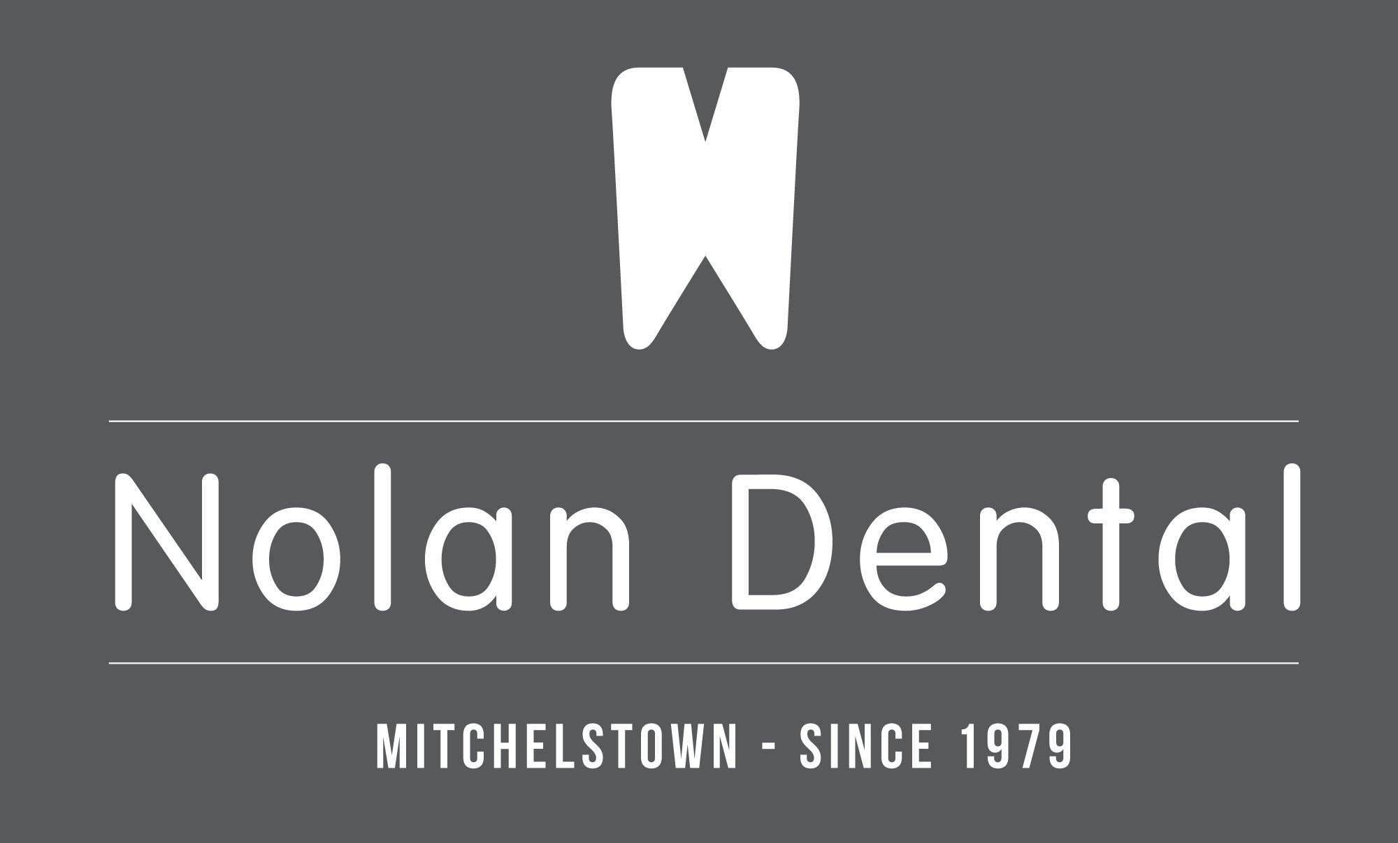
Phone: (025)24519
Postal Address: 50 Lower Cork St., Mitchelstown, Co.Cork
Sections should be expanded to provide more space for detail
Endodontic Referrals – Nolan dental
Patient Name
Patient Address
Patient Phone:
Patients Date of Birth:
Patient Medical History:
Reason for Patient Referral:

Referring Dentist
Dentist Phone:
Dentist Email:

Address: 50 lr Cork st Mitchelstown Co. Cork | Phone: (025)24519

